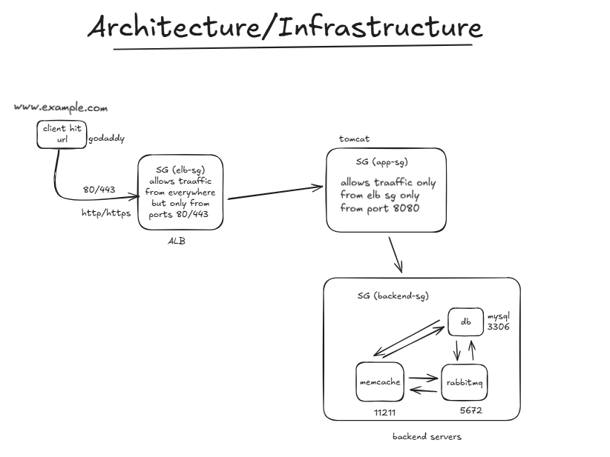

Security Groups

Instances

Networking

GoDaddy

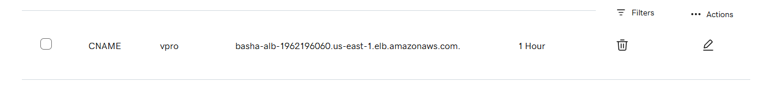

Route 53

Application properties files

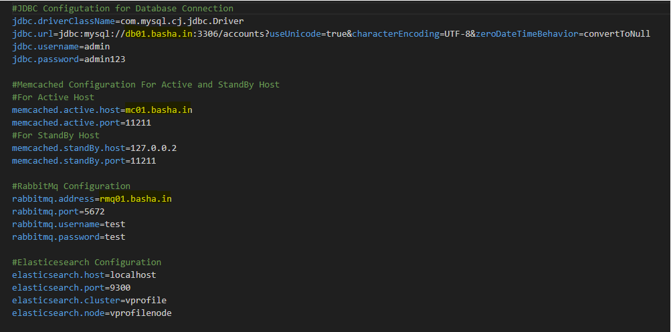

Website checks

Login page

Welcome page

Users

Checking rabbitmq server

Checking memcache service

Added one more user (dummy-1)G

